**Prelab 6 AC Signals, Transformers and Bridge Rectifiers**

**Nolan Anderson**

**February 24, 2021**

---------------------------------------------------------------------------------------

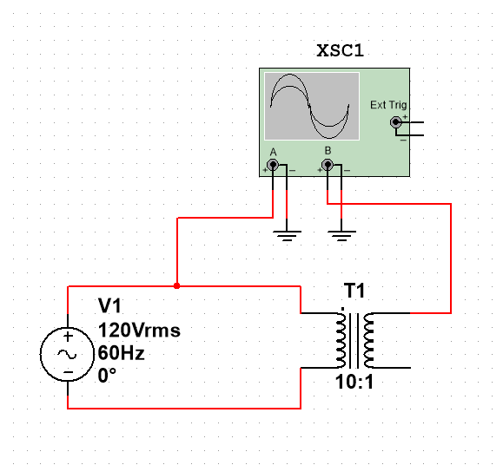

**Circuit 1: Figure 6.1 In Multisim**

**Part 1 – Transformer Figure 6.3**

|  |
| --- |
|  |

Figure 1: Peak Voltage graph Figure 6.3

|  |
| --- |
|  |

Figure 2: Period from Frequency Counter

|  |
| --- |
|  |

Figure 3: Frequency from Frequency Counter

|  |
| --- |
|  |

Figure 4: Node C vs. Node D

Figure 4 shows that Node C and D are off by 180 degrees and perfectly out of phase. The difference between the out terminals of the transformer is just sign.

---------------------------------------------------------------------------------------

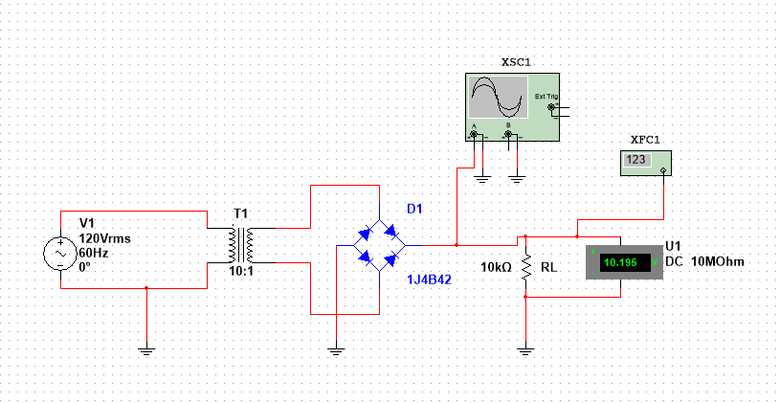

**Circuit 2: Figure 6.4**

**Part 2 – Transformer Figure 6.4**

|  |
| --- |
|  |

Figure 5: Peak Voltage graph Figure 6.4

|  |
| --- |
|  |

Figure 6: Period from Frequency Counter

|  |
| --- |
|  |

Figure 7: Frequency from Frequency Counter